**Cardergy Interactive Tool Report**

Team: Alex Indihar, Tevon Walker, Jeb Watson

# Tool Concept

* **Tool Description**: Cardergy is a greeting card service that allows users to find, edit, and send greeting cards from templates containing special greeting messages. The greeting cards are mailed to the user or the person of interest. What makes this unique is that the greeting cards are the size of a credit card. One purpose is to reduce the amount of time a user would need to find and send a greeting card to someone to under 60 seconds. In addition to this, the greeting cards are outfitted with QR codes that link to a special video message left by the user. A unique feature is that Cardergy is a hybrid of virtual and physical social networking; a user can add another user in Cardergy and send a greeting card to that person without ever actually knowing the recipient’s physical address (this expands the idea of someone sending a greeting card to someone from anywhere).
* **Tool Story/Scenario:** A user is looking for a greeting card for a specific occasion. Normally, this user would travel to a store that sells greeting cards, purchase a pre-made greeting card, and have to mail it or physically hand it to the recipient themselves. With Cardergy, the user only needs roughly a minute on their smartphone and is able to accomplish the same thing.
* **References:** Snapchat
* **Genre:** Social Messaging, Photo & Video
* **Target audience:** Ages 18 to 60, Smartphone users, Internet meme culture
* **Key features:** Fast greeting card sending, video upload, in-app store to select card style

# Game Mechanics

* **Screenshots**
  + 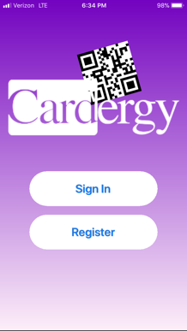 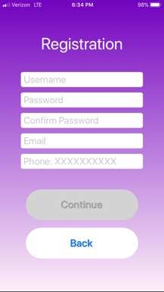 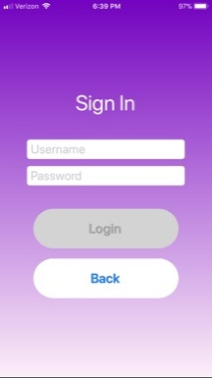 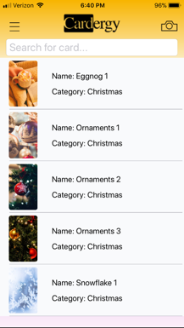 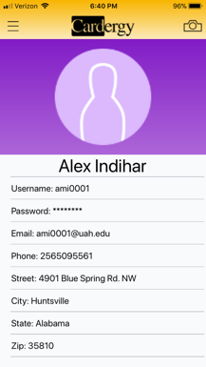 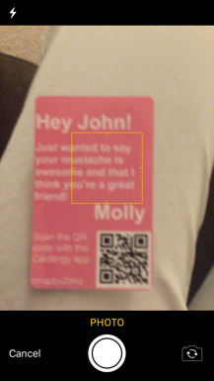 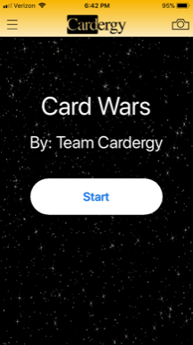 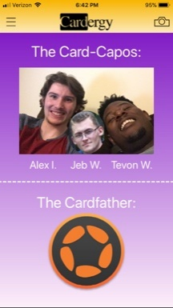 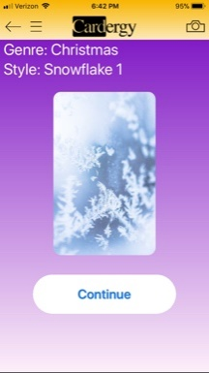 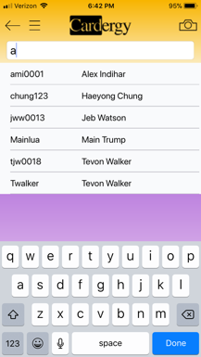
  + 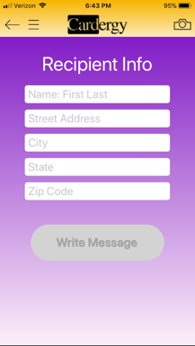 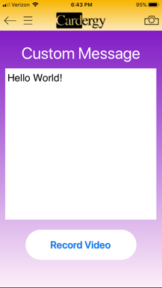 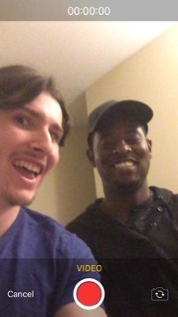 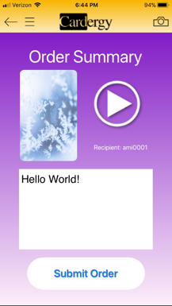 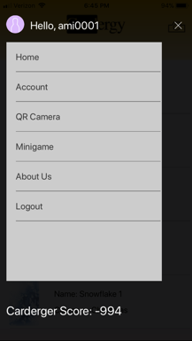
* **Tool Concept Example**
  + Take a video of yourself for the recipient.

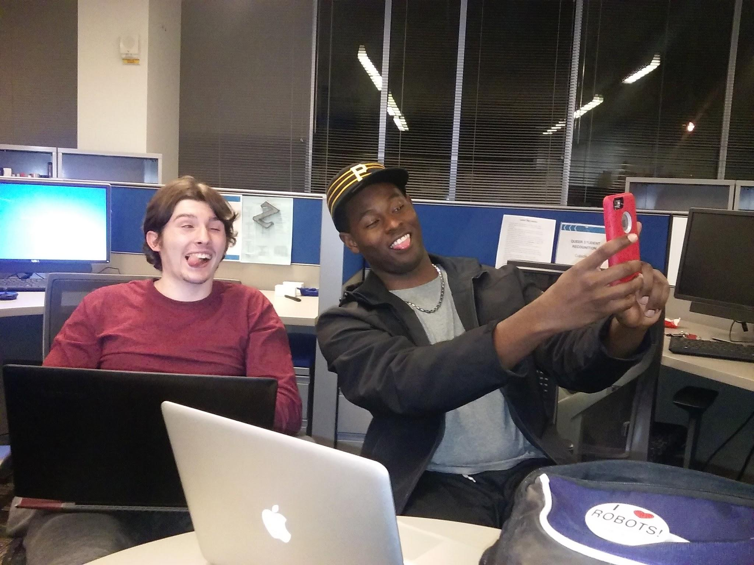

* + Make a personal video to send to your pals and check that your video is as it should be.

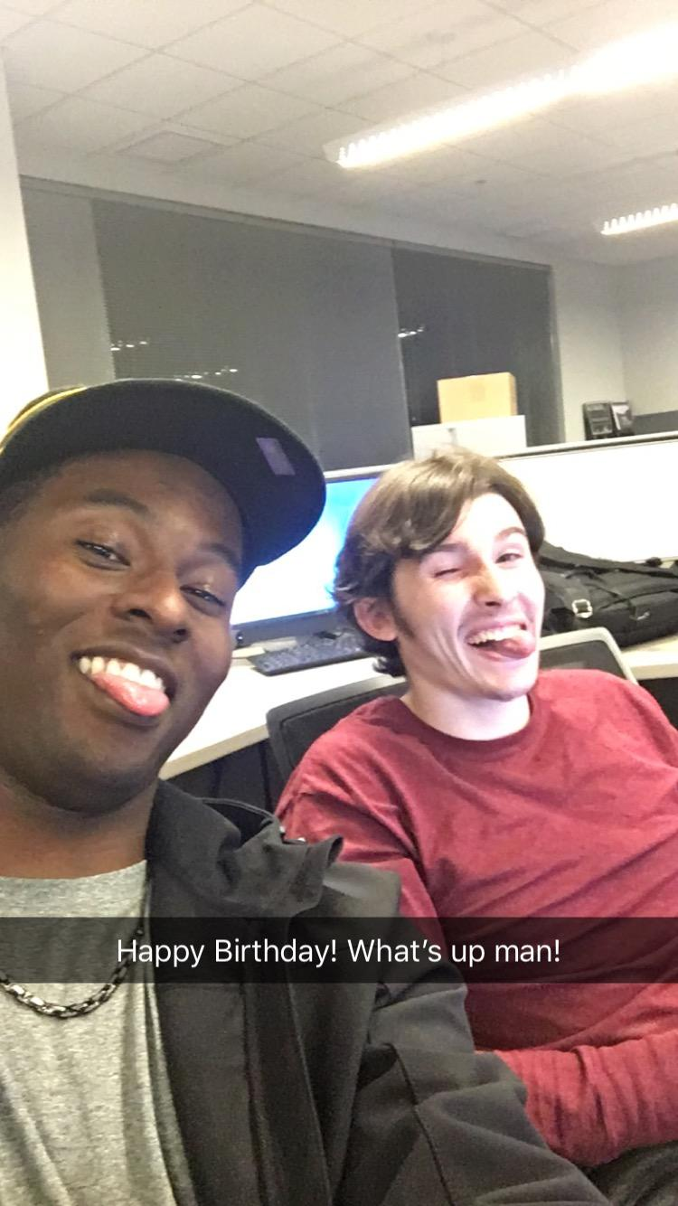

* + Cardergy will create a QR code that contains a link to a personal video.

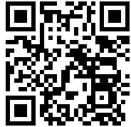

* **Control Scheme and Interface**
  + The user registers and logs in into the app.
  + The user picks a greeting card design from the home screen.
  + The user writes a custom message to be written on the card.
  + The user records a video to upload to the server.
  + The server processes the video, stores it in a database, and generates a QR code for the video.
  + The company forwards the chosen greeting card to the intended recipient.
  + The recipient receives the card and scans the QR code using the app.
  + The recipient is referred to a link to the video from the original sender.
* **Scoring:** Points are given to people who create and send the videos. The points are awarded based on if the video is successfully sent by the sender. The points attributed to the carderger’s (Cardergy user’s) score.
* **Screen Flow**

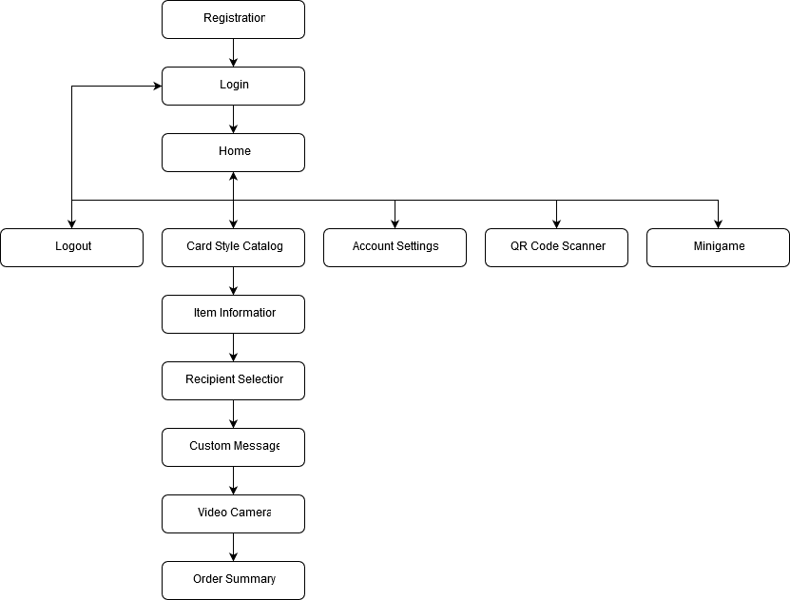

* **Tool Flow**

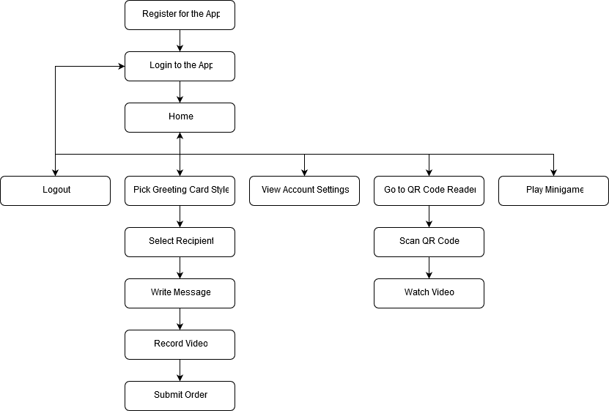

# Tech

* **Technical Aspects**
  + Camera: Used record the videos to be sent out.
  + Networking: Used to send/receive videos across the Internet
  + QR Code Processing: Used to read the QR codes received on the cards from the senders of the cards
  + Video Uploading: Used to upload videos to the database
  + File/Database Management: Used to manage QR codes, videos, etc. in the database
* **Development Resources**
  + Hardware: Specialized production printer for the cards
  + Software: Server to host the database (hosted by XAMPP)
  + People: Us
  + Networking: LuaSocket for networking protocols
* **Project Schedule and Milestones**

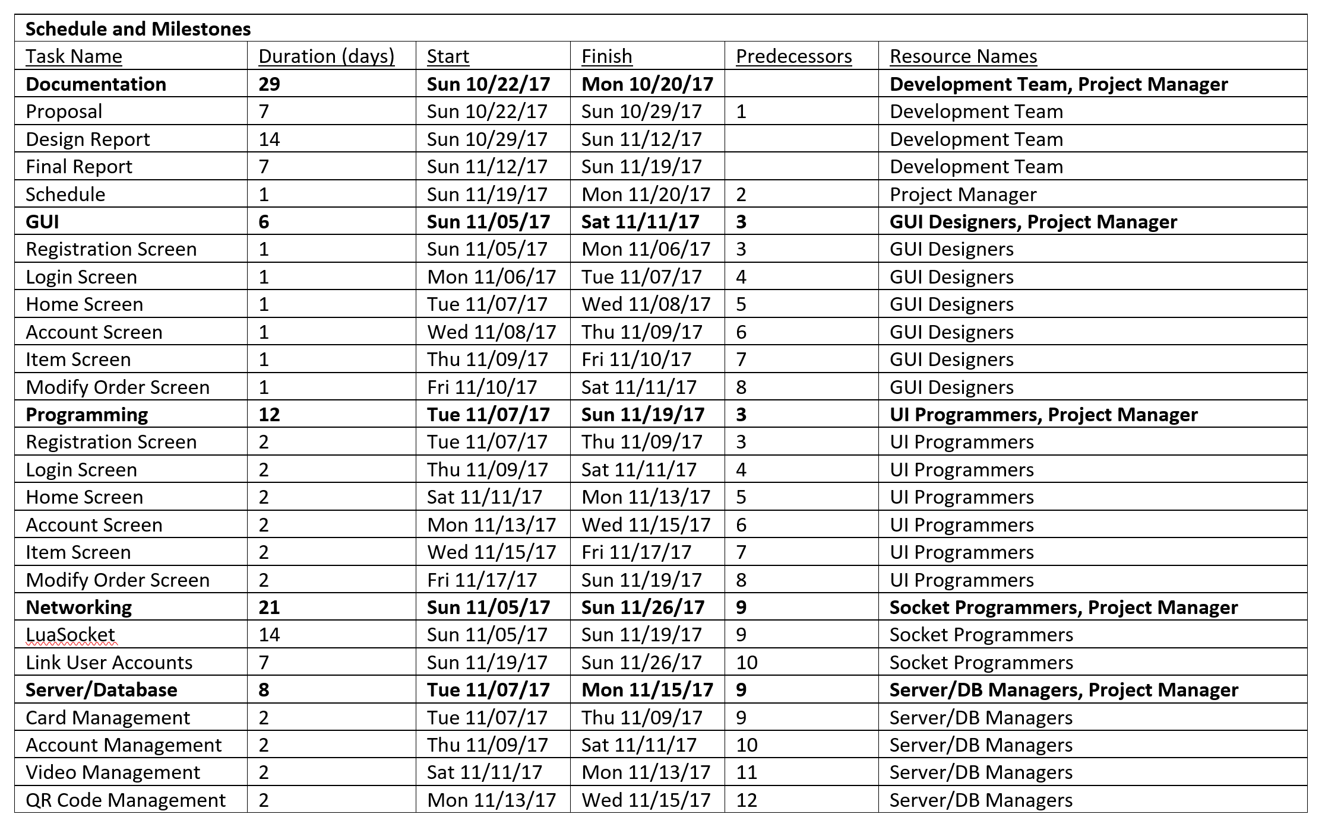

* **Asset List**

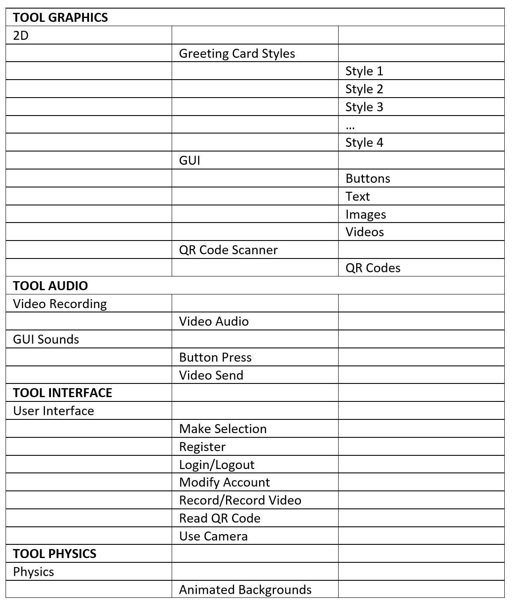

# Discussion

* We were not able to add a friends’ list due to time constraints. We had to spend time on more important features
* We compensated for missing friends’ list with a mini-game

# Team Collaboration

* + Alex Indihar
    - Database/Server Development
    - Networking/Backend (PHP)
    - GUI
  + Tevon Walker
    - QR Code Interpreter
    - Networking/Backend (Python)
    - Video/Camera
  + Jeb Watson
    - User Experience
    - GUI